Sloped Ball

For our game, we made a side-scroller, mouse clicking obstacle course. The objective is that the player has to get a red ball to the finish line with the least amount of jumps while avoiding spikes along the way. We originally planned to have a few more traps for our game but we want to keep it as minimal as possible to keep it close to the chosen theme.

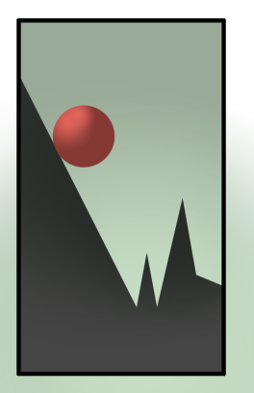

Few changes:

* **Less Traps:** Fewer traps to keep it basic for prototype

and minimal to our theme. Ease of control

* **Modular slopes:** We originally experimented with

using BSP to block out our level but building modular

assets proven better.